**1.Login**

- Login with correct username and password of dealer to use this web or app. Here for some demo account for testing:

For admin:

|  |  |
| --- | --- |
| Username | Password |
| mod | 1 |
| admin | 1 |
| editor | 1 |

For user:

|  |  |
| --- | --- |
| Username | Password |
| user | 1 |

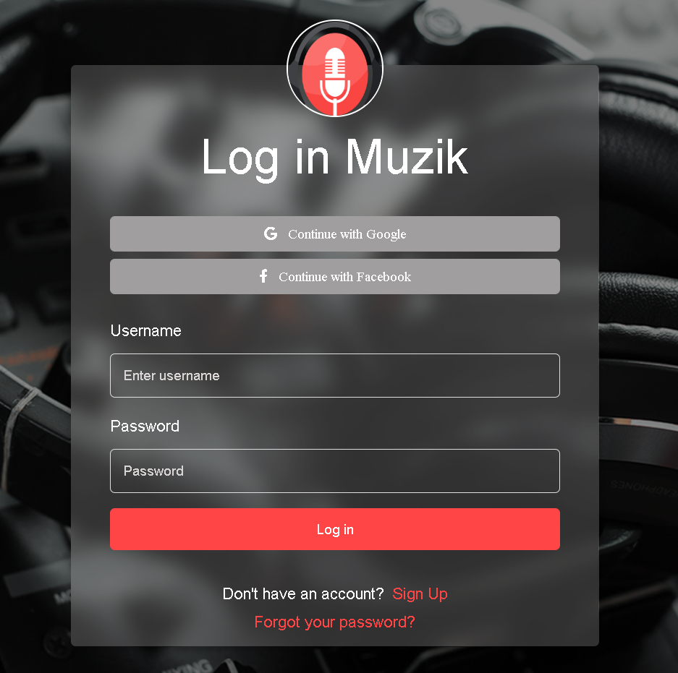

Music Web on Website

1.Client

1.User can view Homepage,Product,Genre,News,Contact,Promotion without login in

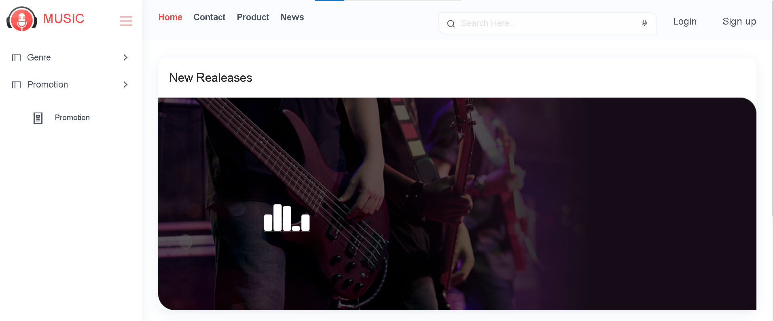

2.After Login User can see user’s Manage Account

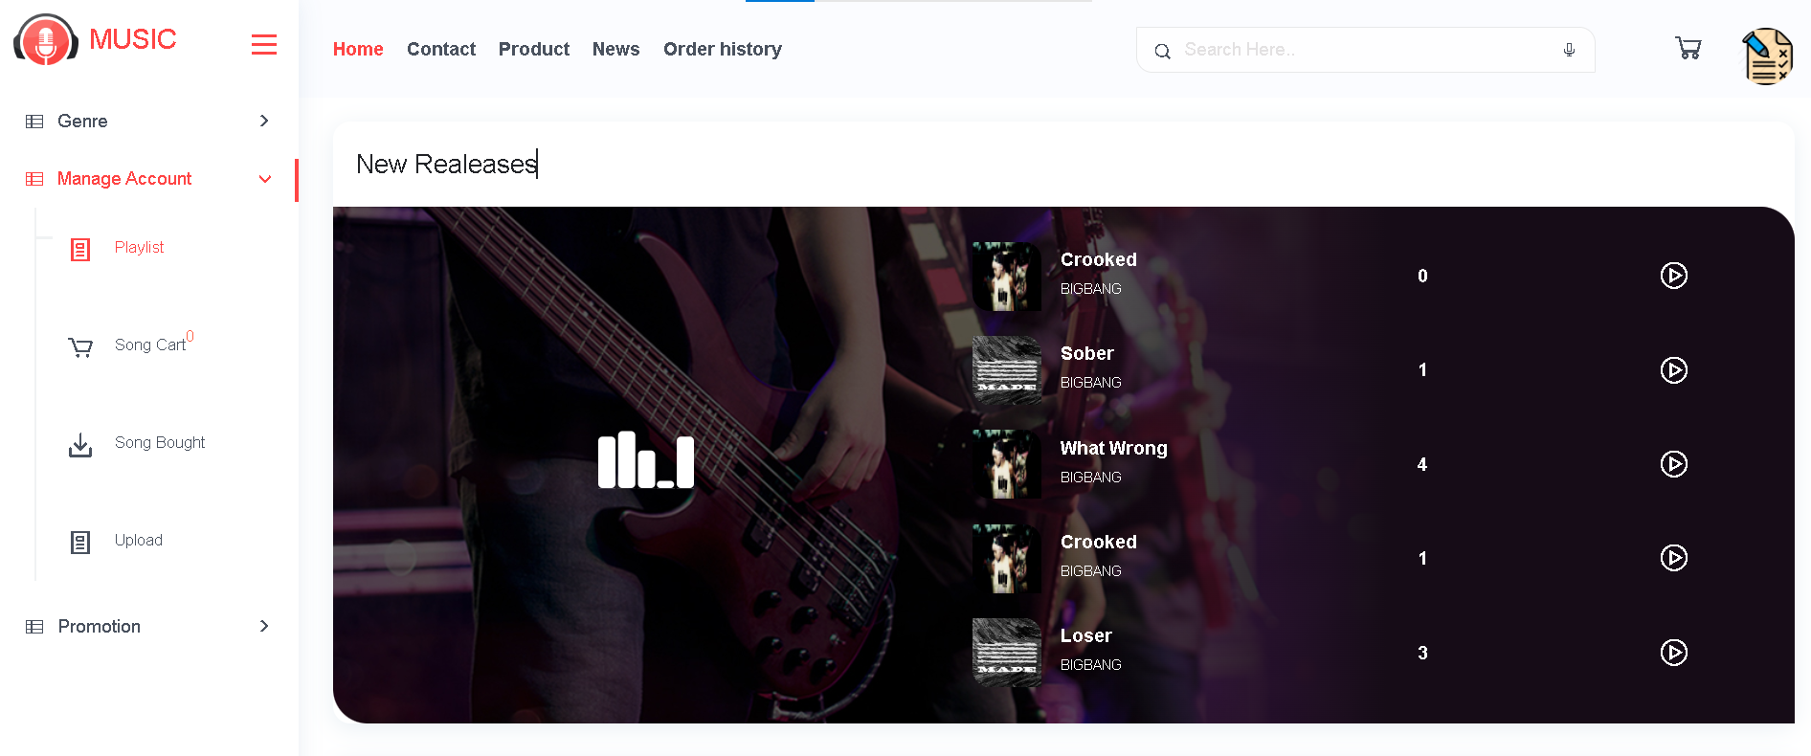

3.User can listen song when click on each song and user can next song,play song,see list song available……

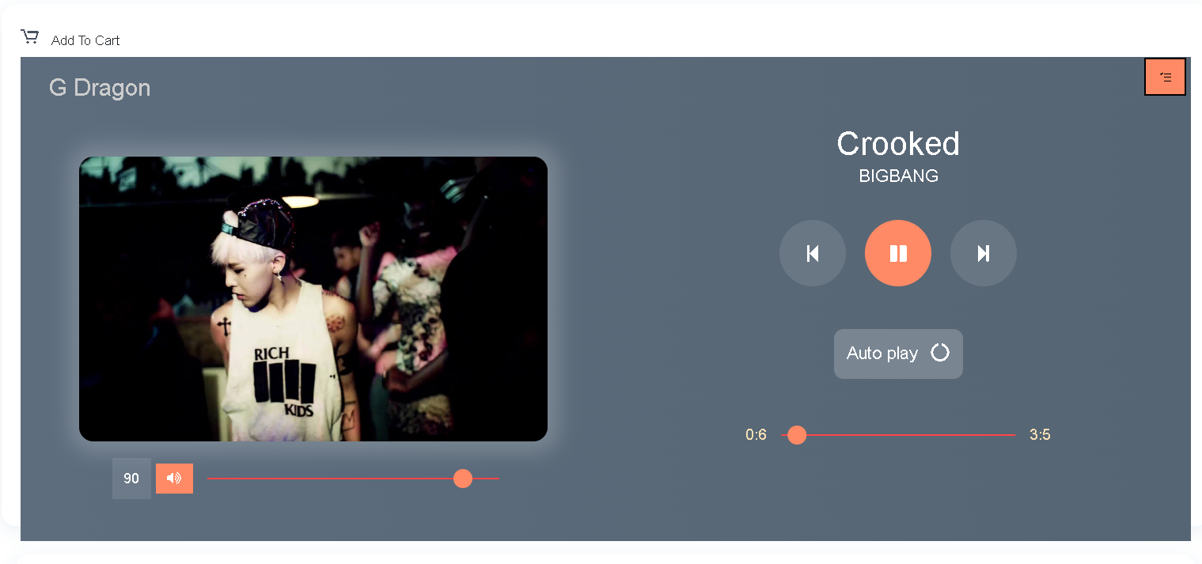

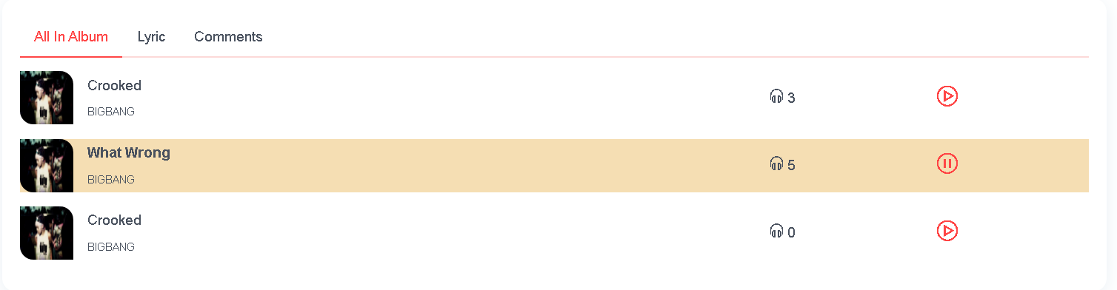

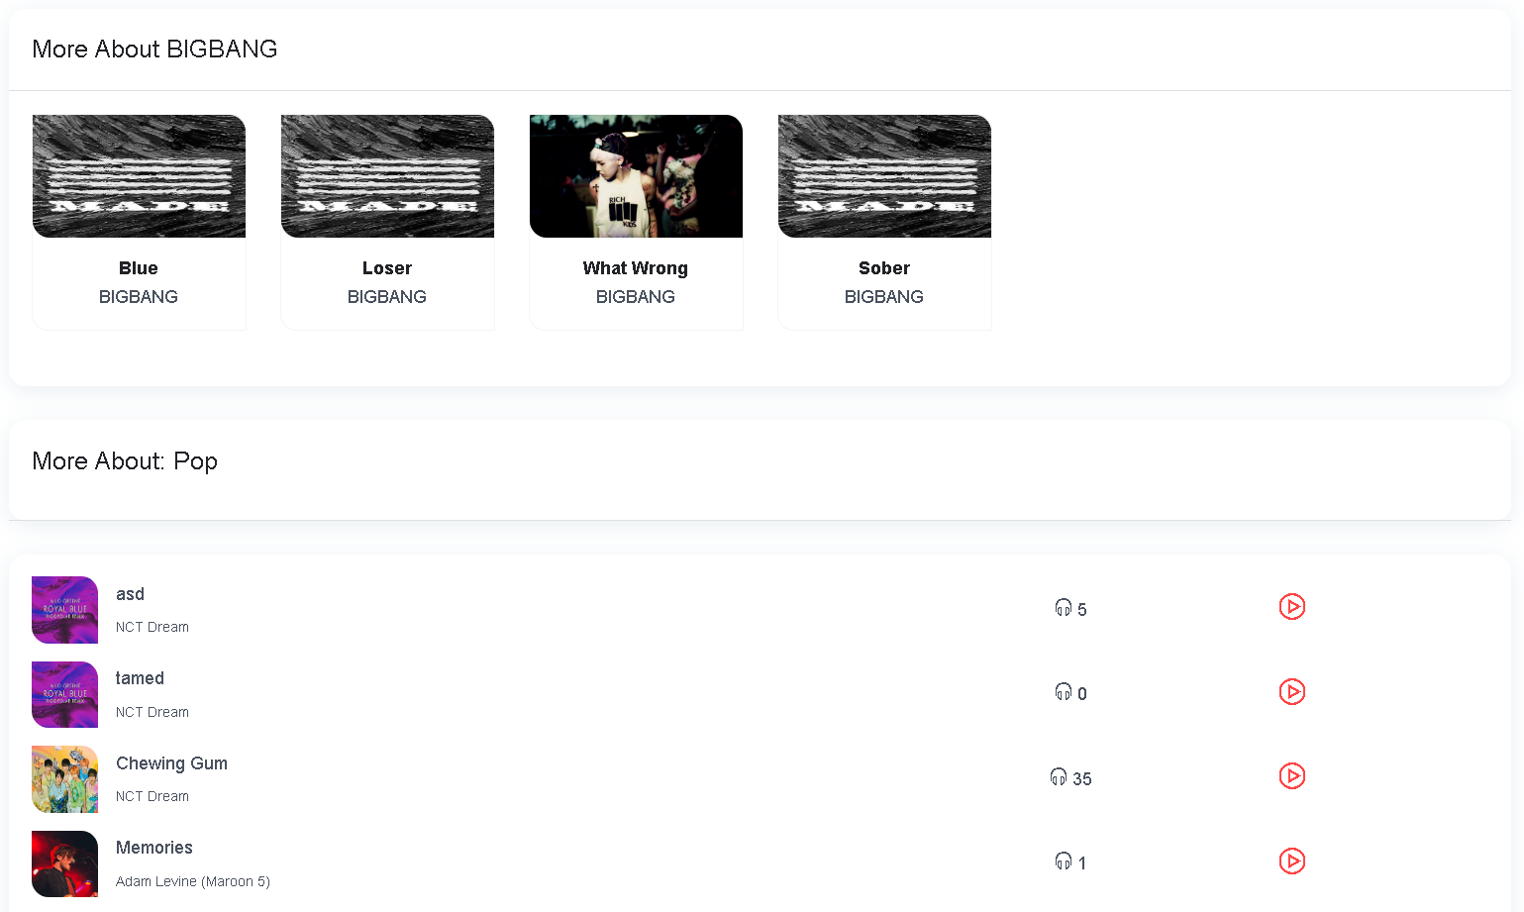

4.User can add song to Playlist available by tick on checkbox or Add new Playlist by input name Playlist and click on Save changes button.

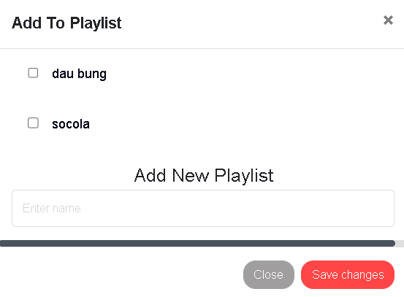

And User can see the new the playlist or new song in Playlist Page

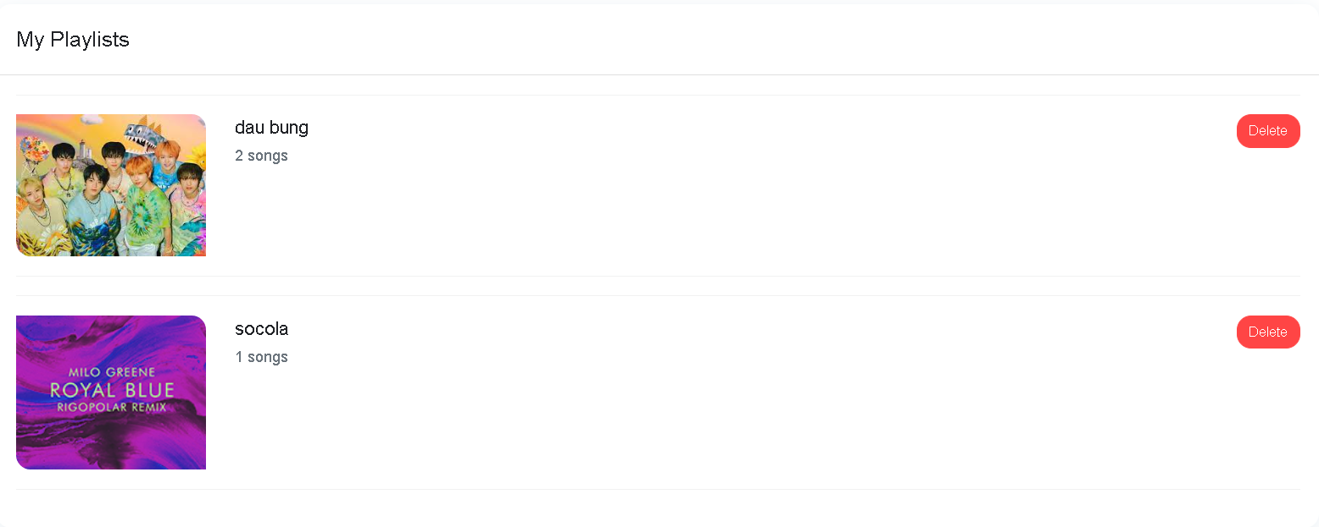

User can listen when click

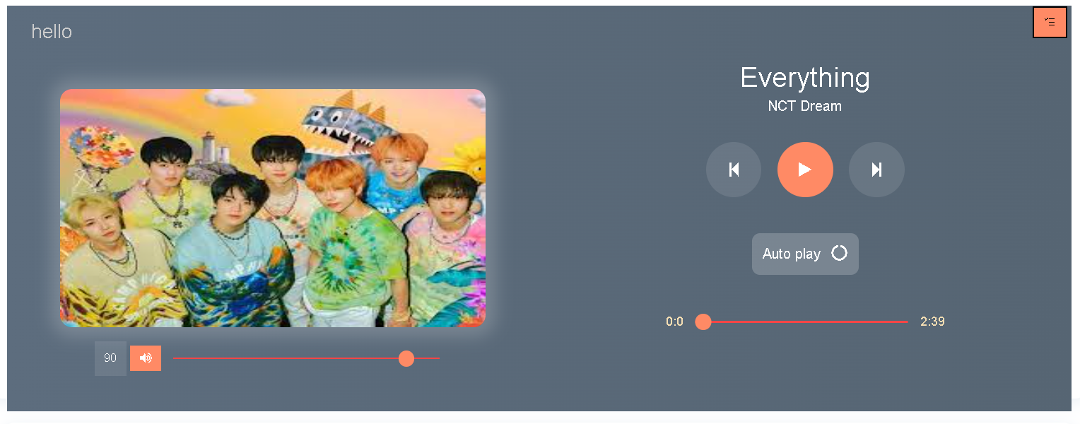

5.Another that,user can add song to cart if user like this or user can cancel add cart by click once.

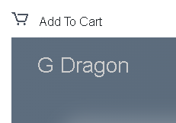

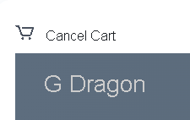

6.After add song to Cart user can see your cart in Song Cart in Manage Account.

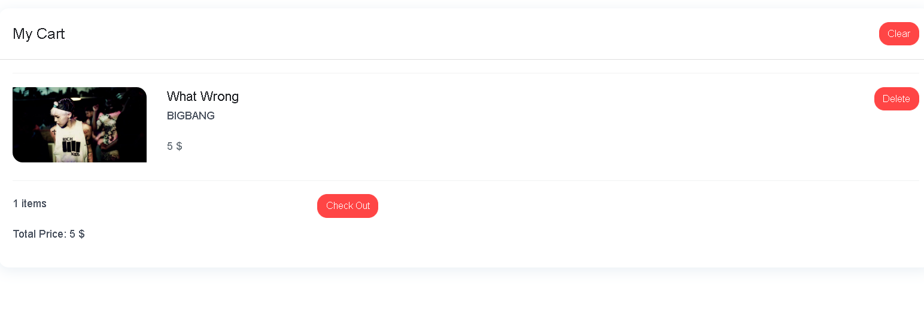

When user click on checkout button ,Checkout page will is on and user can see your user information ,total price to check out,if user have discount code user can input .And then user click button order with Paypal,user will be redirect to paypal page to Checkout.

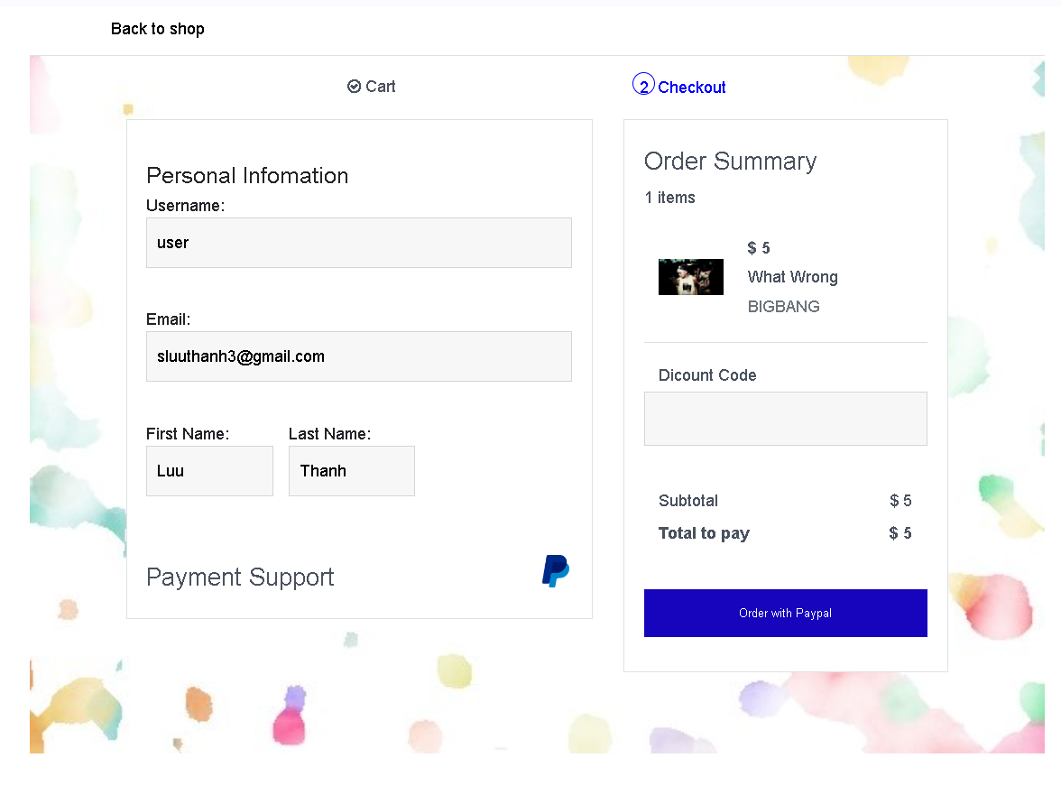

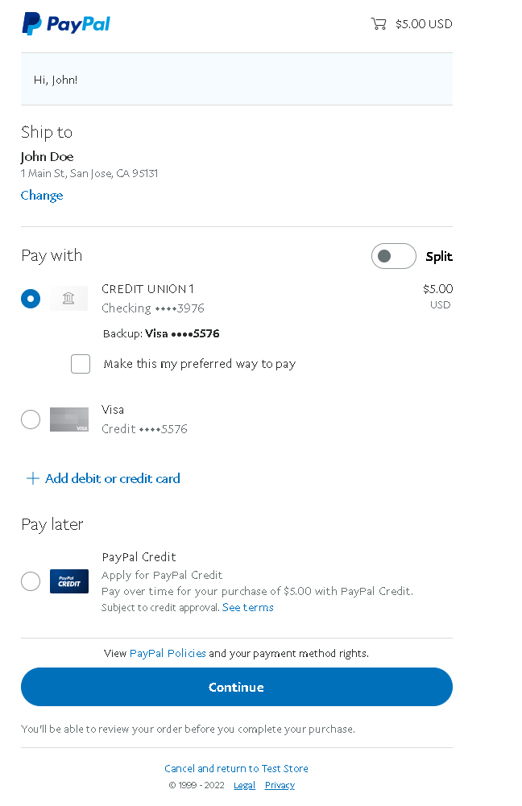

7.After checkout success user can see song buyed in Song Bougth and User can download it by click on download.

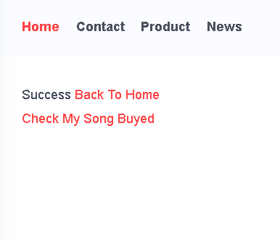

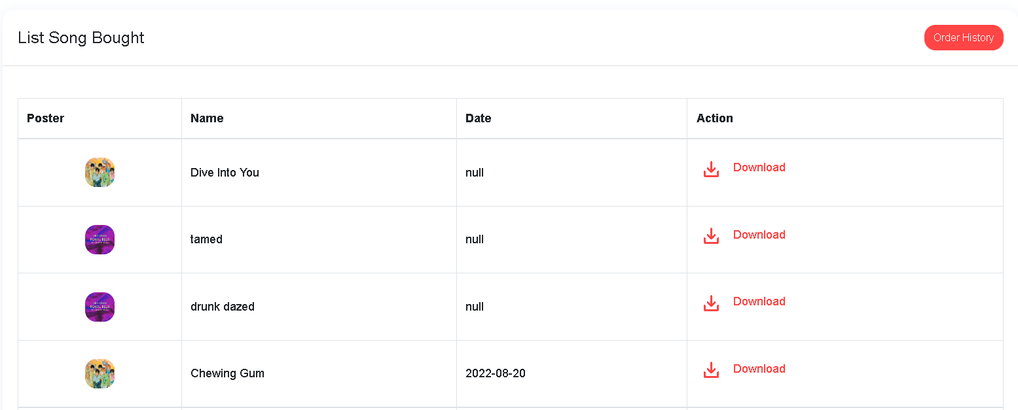

User check my order history by click on button Order History

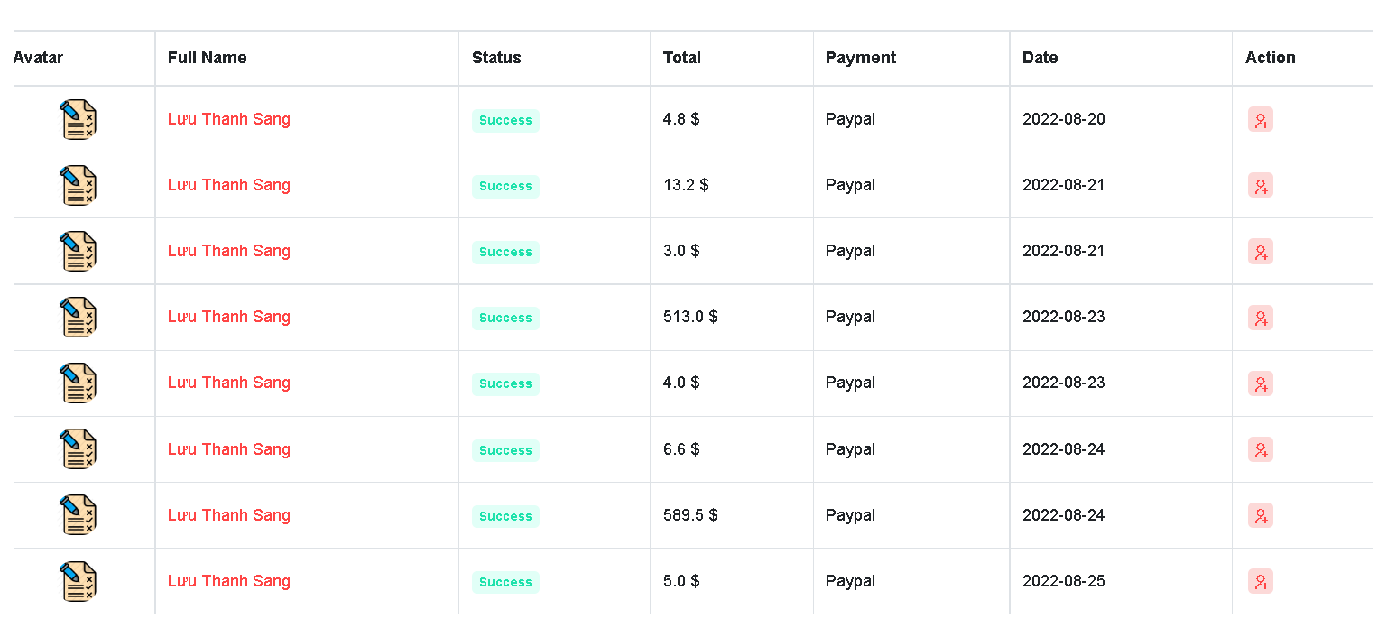

Another that user can check order information if they want by click symbolize in Action

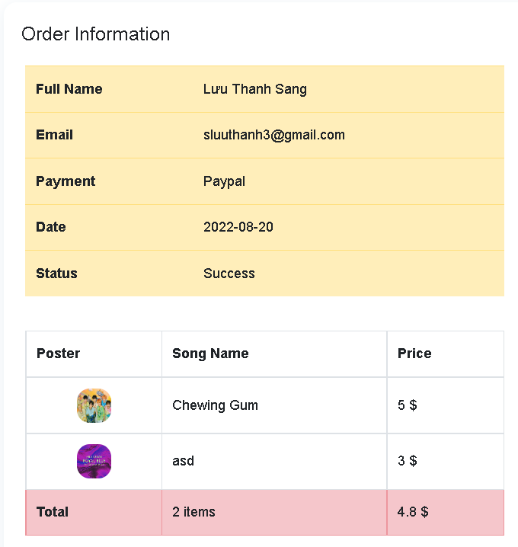

8.Moreover,User can see list Genre and Genre of song,User can refresh to see new random list genre of song and listen.

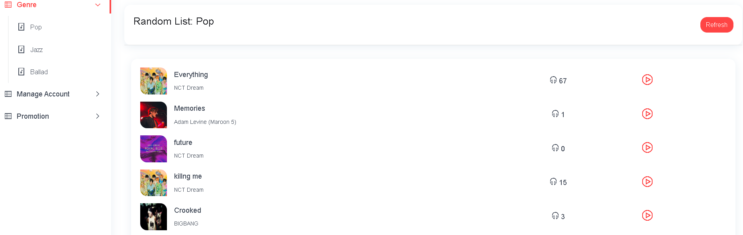

9.And no less important is Upload Song for user,this is a page allow user can upload song user like to the web.

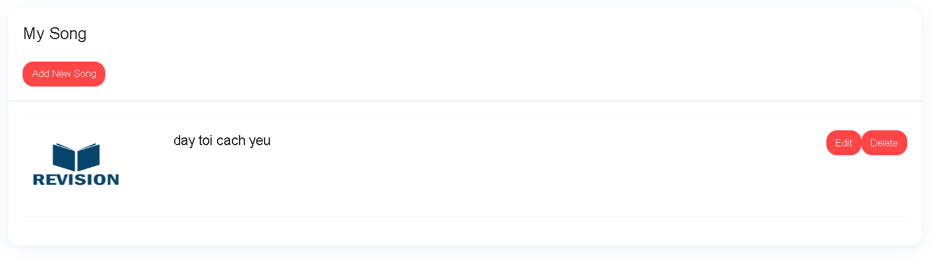 If User don’t have any song ,the web will show user don’t have song

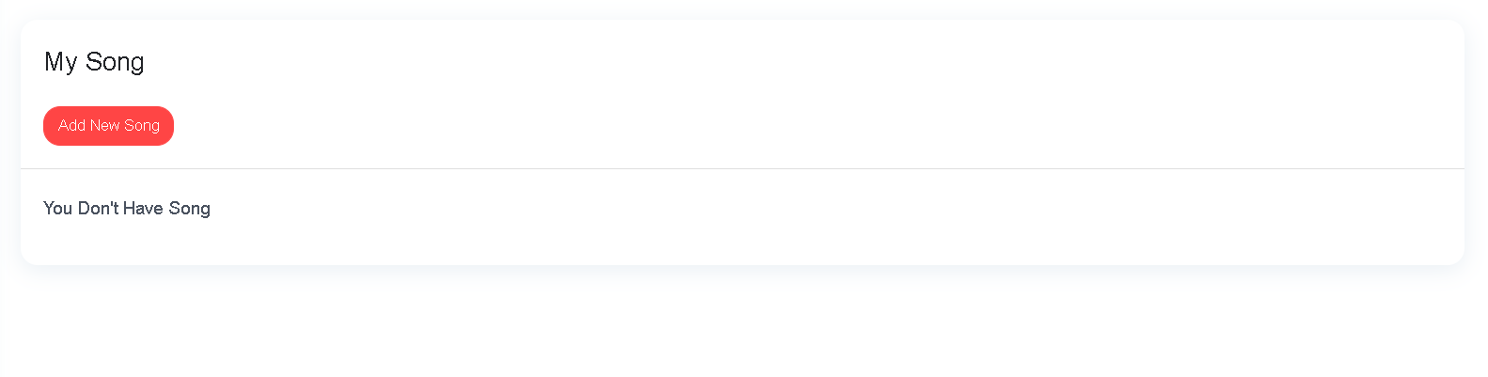

User can add new song they like by a way click on button Add new song.

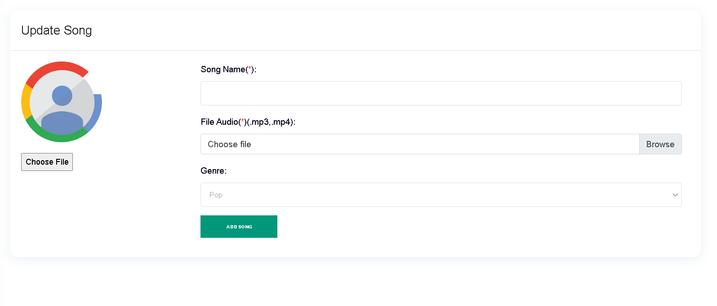

10.User can get promotion gift code in Promotion page for buy song.

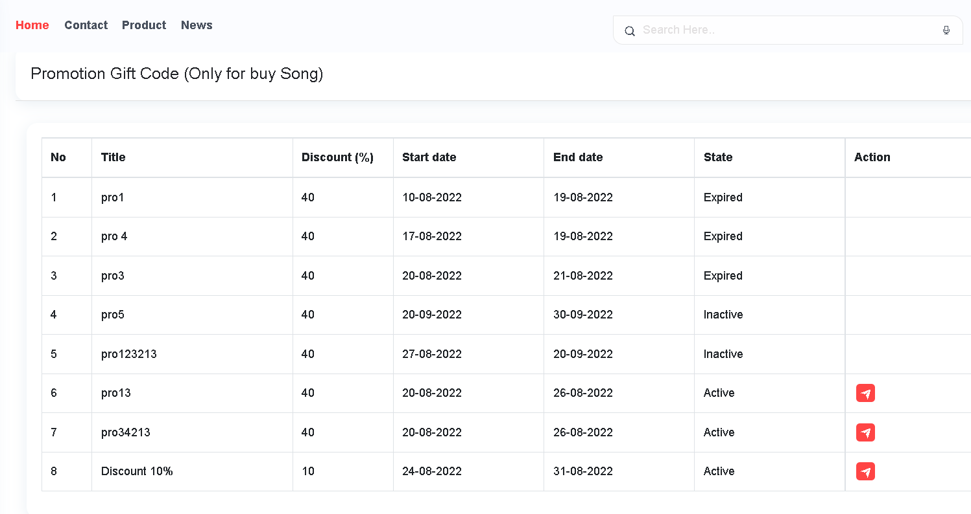

When user click to get code ,code will be get.

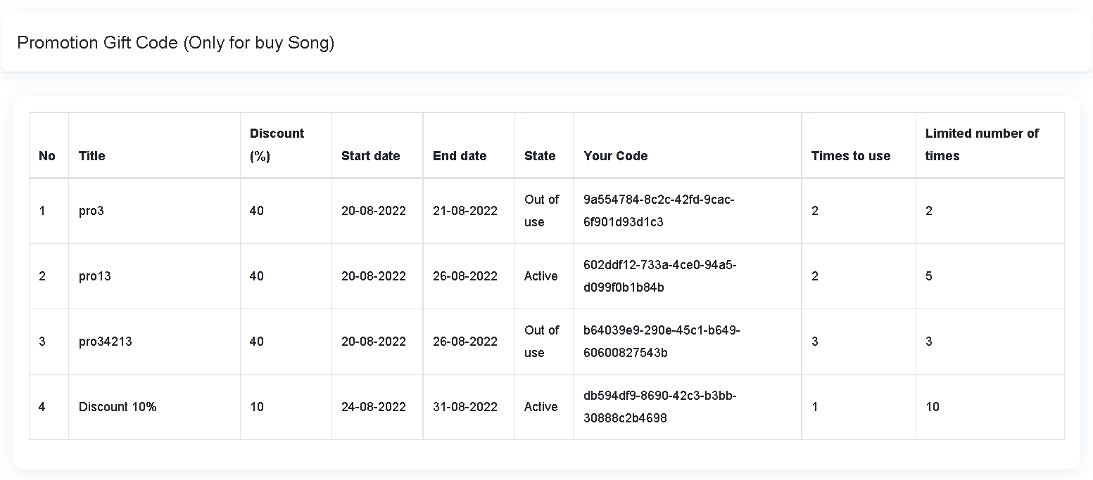

11.User can see all product available and click on each product to see product detail.Select Product By Category

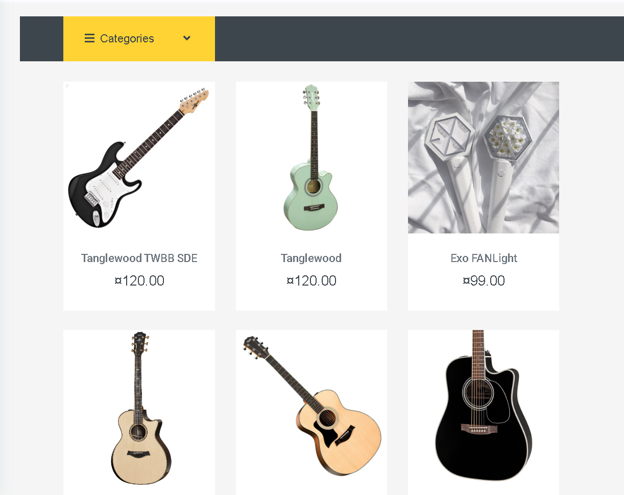

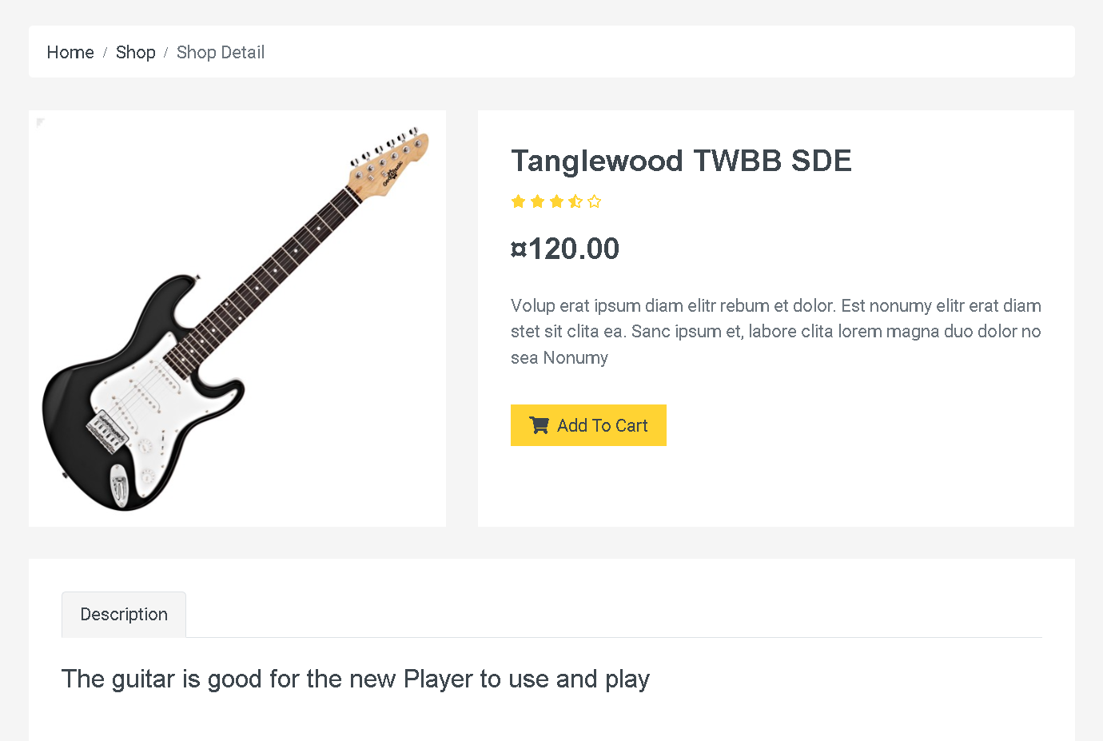

11.When user click Add to cart ,product will be add to cart

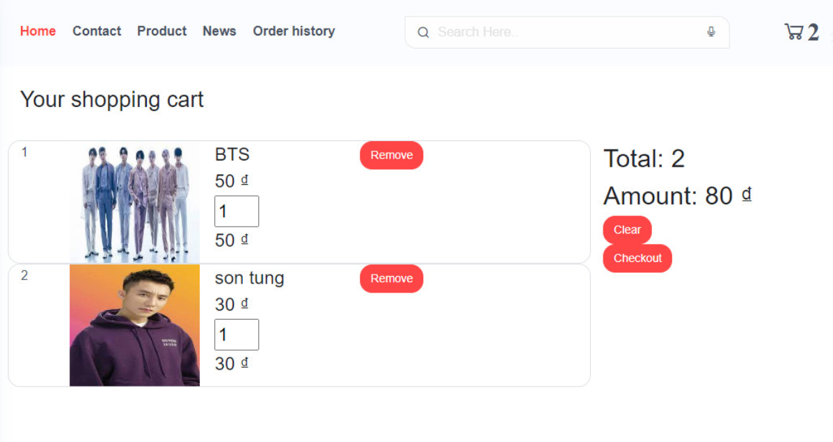

User can check out by click on button checkout user will be redirect to checkout page.

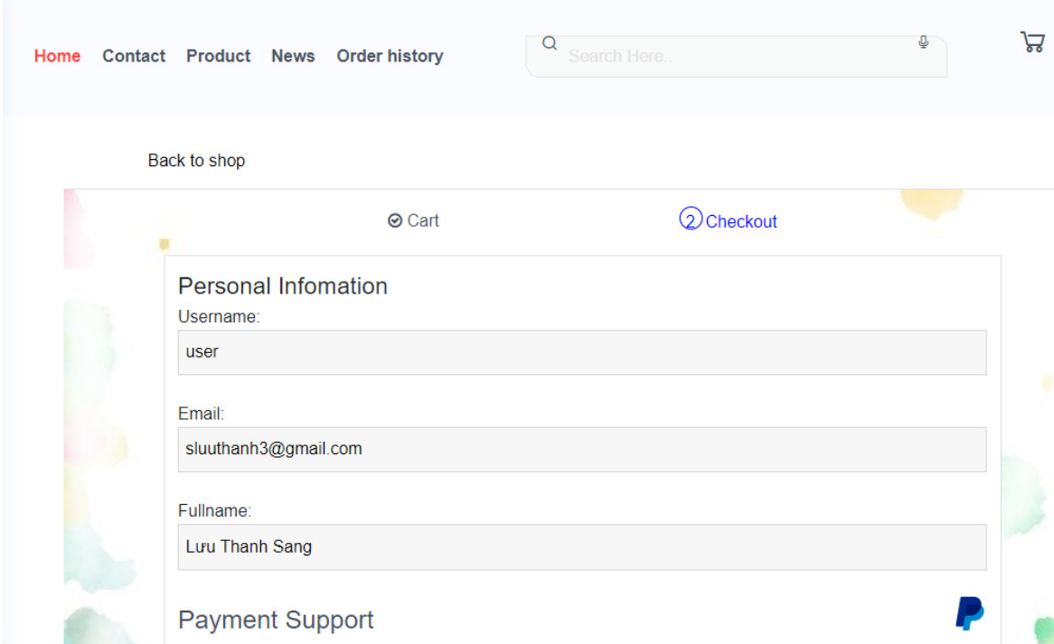

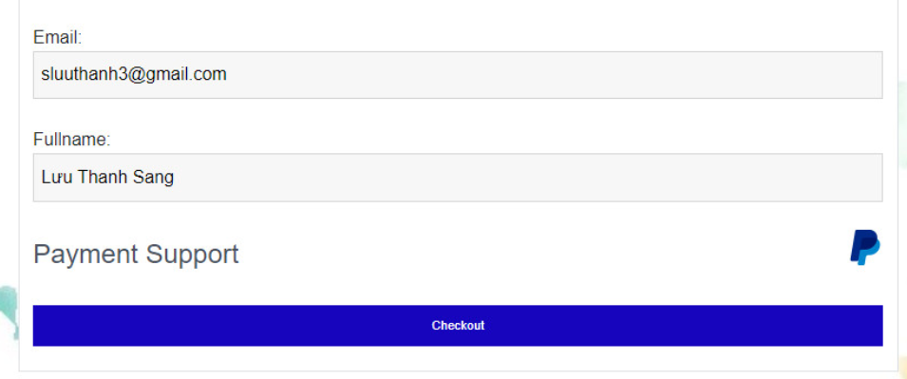

When User click on button Checkout user will be redirect to Paypal to checkout.

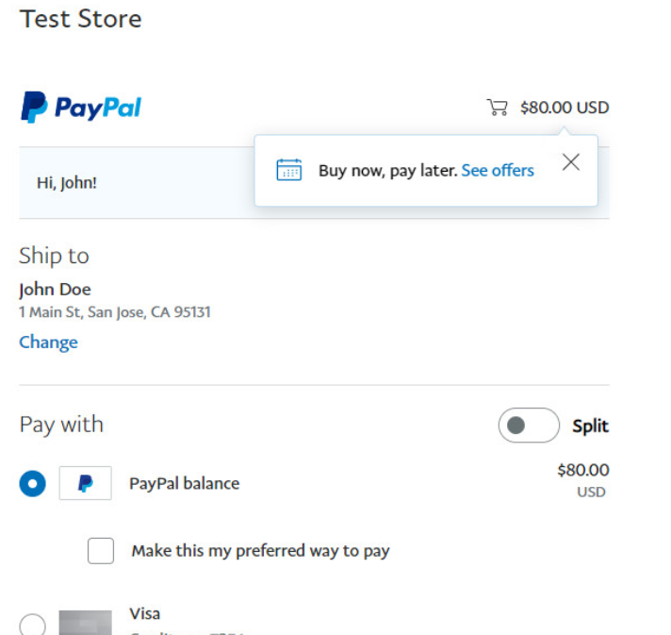

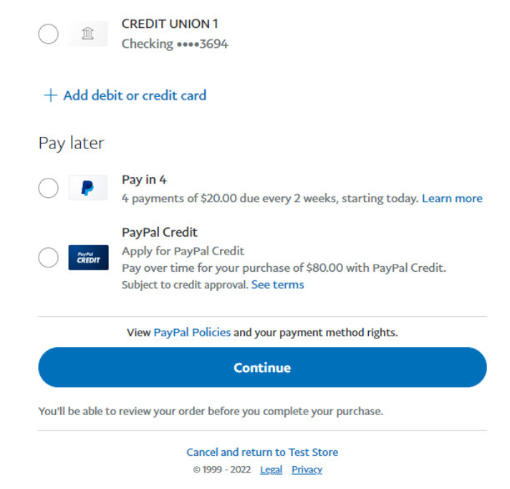

After checkout user will be continue redirect to page if success

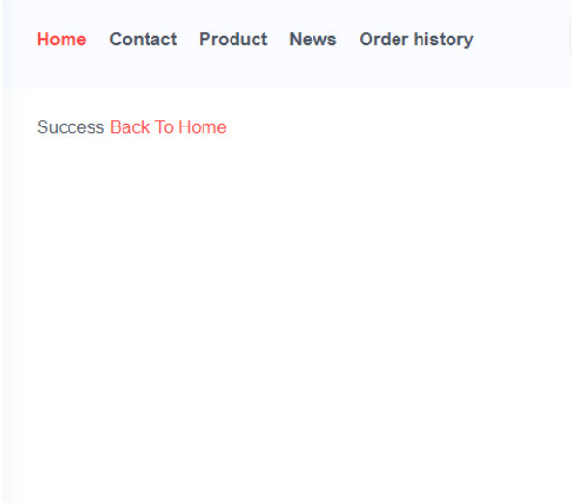

12.User can see News about Artist,Song,….and News details when click on Title.

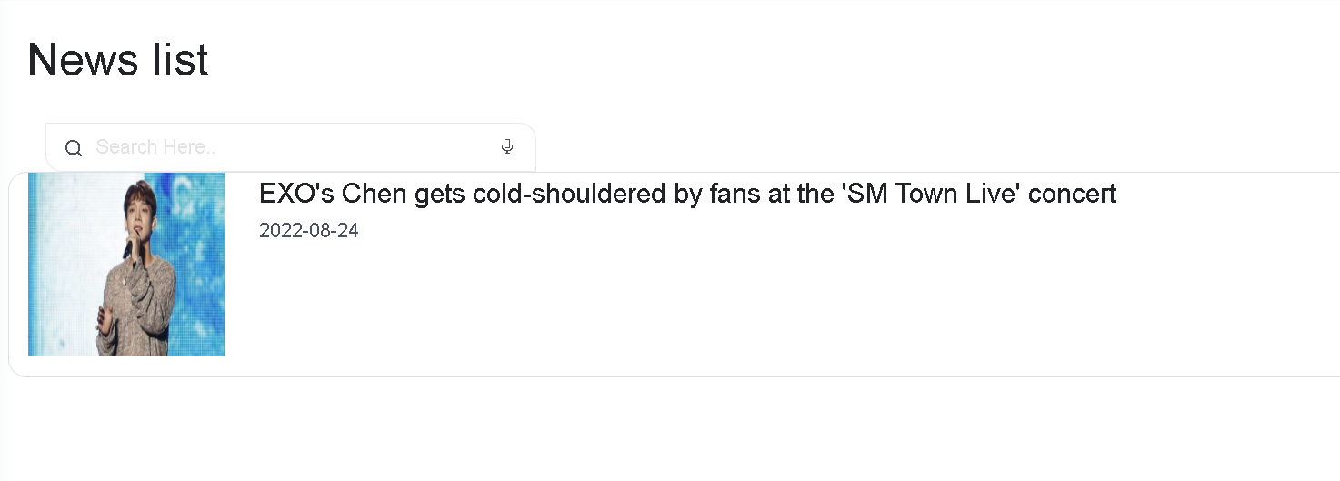

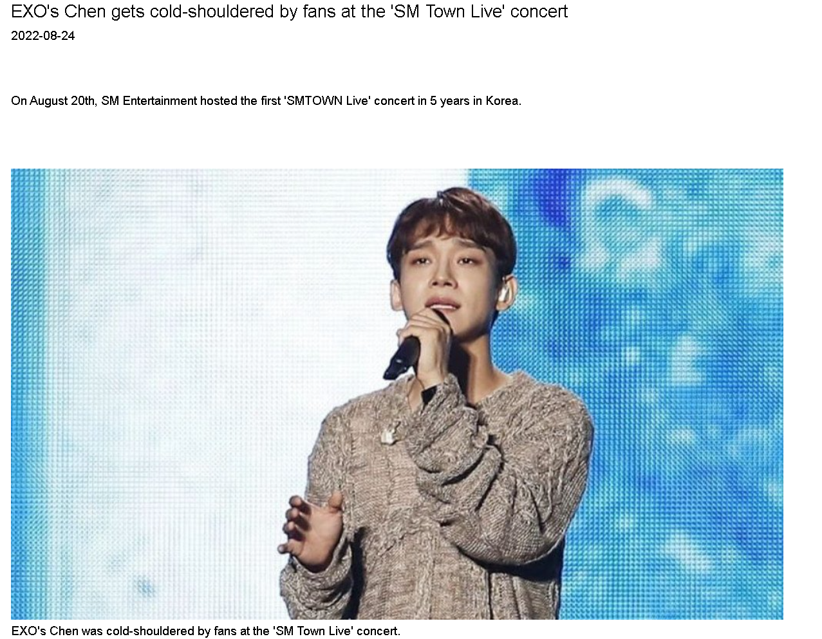

2.Admin

After Login Admin

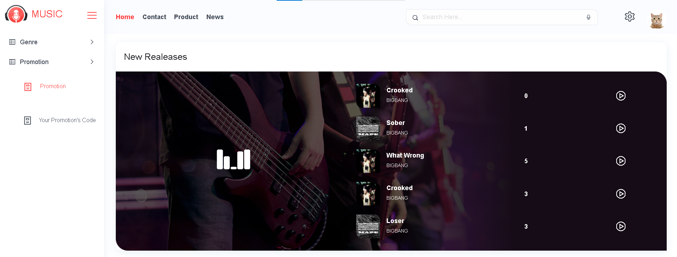

Music Web Android App

1.If user don’t have account user can regiter here

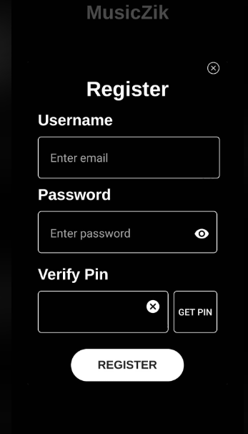

2.If user have account user can login here.

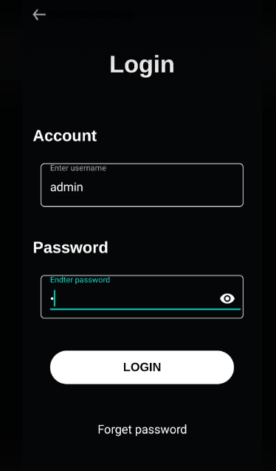

3.After Login User can view homepage app.

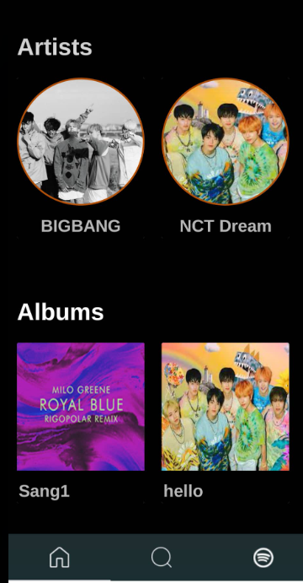

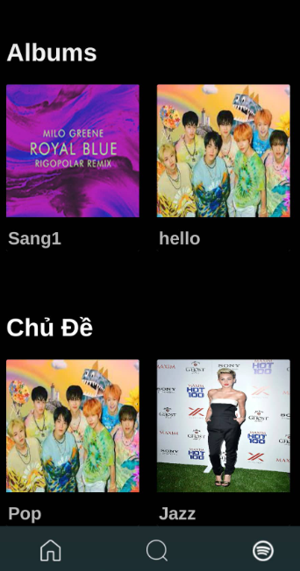

User can view artist,album,genre and list song of artist,album,genre. when click song user can listen song

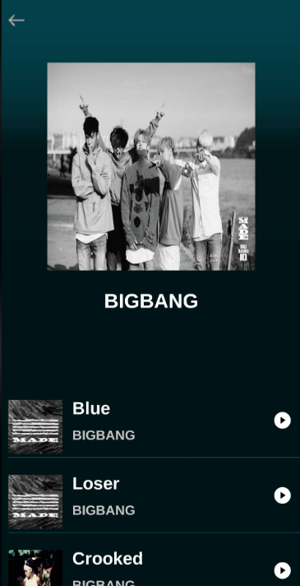

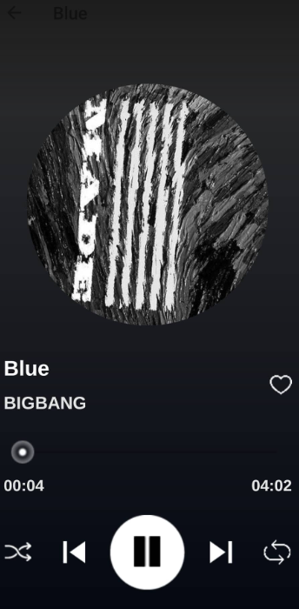

Another that User can search song.

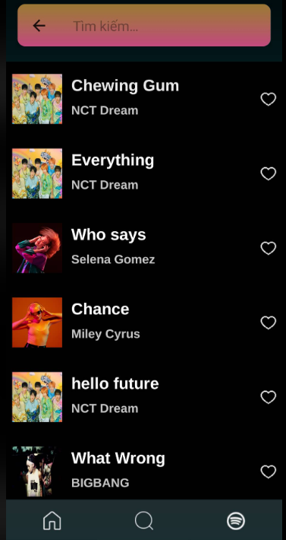

And finally is page Log Out

